**Vaping and Young People**

**Information and Support for schools in Oldham**

1. **Background**

This document aims to provide schools with the facts on vaping in young people. It will provide an overview of the current situation and support offers available in Oldham. It has been developed following several incidents of young people collapsing and feeling ill after using unregulated or unlicensed vapes. These vapes might consist of higher than usual amounts of nicotine causing the young person to become ill. Some of these vapes may also contain other substances i.e. synthetic cannabinoids.

This document will be updated as new resources become available.

**How to use this document:**

Please note, there are several links embedded within the document containing information and resources to support schools. They have not been included in full to enable ease of navigation.

It is recommended that designated safeguarding leads, school nurses and anyone with a key role in supporting young people with their health familiarise themselves with the document for ease of use.

1. **Vaping: The facts**

2.1 The following is taken from the ASH Smokefree GB adult and youth surveys for 2023. **The full headline report is available** [**here**](https://ash.org.uk/uploads/Headline-results-ASH-Smokefree-GB-adults-and-youth-survey-results-2023.pdf?v=1684400380)

* No significant change between 2022 and 2023 in the number of 11-17 year olds currently vaping or smoking.
* However, trying vaping once or twice is up by 50% on last year.
* Disposable (single use) e-cigarettes are the vape of choice for children currently vaping.
* Selling vapes to anyone below the age of 18 is illegal.
* Corner shops are the main source of purchase and child awareness of instore promotion has grown significantly since last year.
* Some young people believe that using tobacco and vapes helps them combat stress. This is a myth – in fact using tobacco is more likely to lead to mental health problems. The feeling of relief from using tobacco or vaping is due to the body’s increasing dependence in nicotine.
* Vapes are less harmful than cigarettes as they do not contain harmful chemicals and tar. However, they should be used as an aid to support tobacco cessation and are not intended for use by young people who may have never previously smoked.

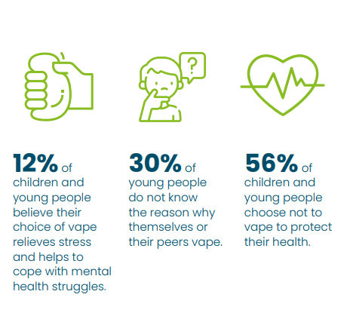*Taken from Health watch Blackpool Vaping report

2.2 This document developed by ASH is particularly helpful in addressing some common misconceptions around vaping [Addressing common myths about vaping](https://ash.org.uk/uploads/Addressing-common-myths-about-vaping-ASH-brief.pdf)

2.3 If you would like more information on substance trends in the Greater Manchester [GMTrends](https://gmtrends.mmu.ac.uk/).

1. **Pathway for emergency support**

This pathway provides an overview of how to support a young person that is using tobacco or vaping. It includes steps that may be followed in case of an emergency.

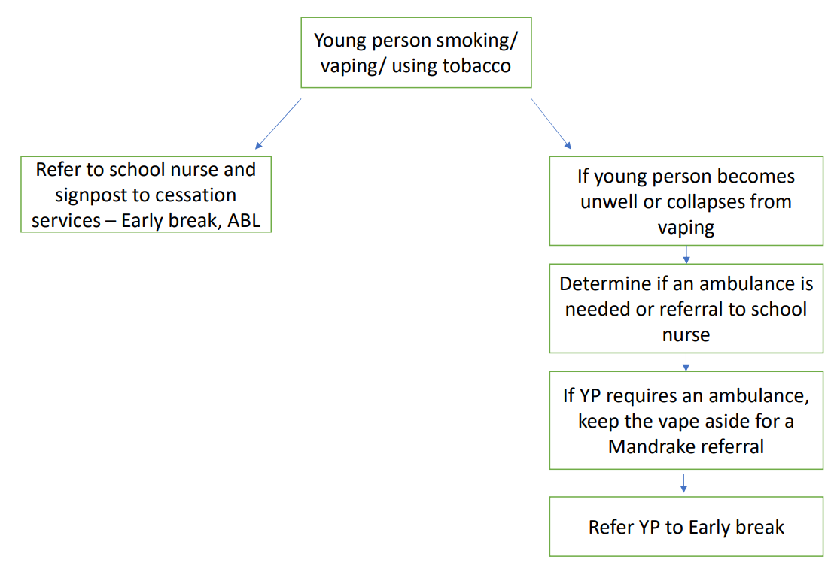

1. **Supporting teachers to tackle vaping in schools**
2. **The Youth Vaping toolkit**

In response to the growing concern in Youth Vaping, NHS Greater Manchester (NHS GM) has published a Youth Vaping Toolkit for use across the GM locality educational and youth establishments.

In recent years, vapes and e-cigarettes have been a successful way of helping many adults to give up smoking. However, the sale and promotion of flavourings, colours and branding, which particularly appeal to children and young people, as well as the illegal sale of vapes containing higher levels of nicotine and high volumes of e-liquid, has initiated a response to do more to protect children and young people across GM.

The toolkit includes:

1. Two Posters on the harms of vaping for children and young people.
2. Short CYP video animation to support classroom discussion and debate.
3. Teacher knowledge presentation, toolkit and lesson notes to support lesson planning and help educators to be discussion ready.
4. Parents and carers information leaflet – which can be shared via newsletters.

Resources are available to **DOWNLOAD HERE:** <https://makesmokinghistory.co.uk/resources-on-youth-vaping/>

1. **Key stage 3 resources on vaping**

Better Health have created [teaching resources](http://links.e.phepartnerships.co.uk/els/v2/pNv7BKX-~6Tr/M0dEb2t1alJDZjkxU1k2YlQ5L1Z3aWNIYjRZd243cUdvcENmMHNFVWFIZFRRTjdpMmszb2IvaExDQm1kU3NUMnVESUhEMVc4KzZ3bFZ4aXNITU8wOURvYXN4RWZBSmtobjZkT1lsZEFBSmQyWmtNUGRMT0REZz09S0/) aimed at helping Key Stage 3 children understand the impact that vaping has on their physical and mental wellbeing. The three curriculum linked resources feature:

* Information on nicotine, what vaping is and the impact it has.
* Films co-created by young people.
* Activities to prompt pupil discussion and reflection.
* Content written and reviewed by teachers.
* Guidance on teaching about vaping.
* Flexibility of use as either short form time activities or a full lesson plan.
* Endorsement from the NHS.

Please use this link: [Mental wellbeing | Overview | PHE School Zone](https://campaignresources.phe.gov.uk/schools/topics/mental-wellbeing/overview#vaping)

**Please note:** It is recommended that schools add a slide with information on key contact persons within the school students and teachers might approach for support and advice.

1. **The role of school nurses**

School nurses play a vital role in supporting the health of young people in education. They are trained to provide accurate, up to date advice on health concerns and will sign post young people to necessary services. School nurses should be consulted in supporting young people with tobacco use, quitting vaping or other products, like shisha.

1. **Support in Oldham**

**Services**

### **Young People’s Substance Misuse Service - Early Break**

#### 13 –19-year-olds (up to 25 years old for special educational needs and/or care leavers)

Early Break offers accurate, unbiased information on all aspects of drug and alcohol use and a counselling, support and treatment service to anyone who feels that they have an issue, question or problem related to drug or alcohol use.

Please send **all referrals** into service are sent to [info@earlybreak.co.uk](mailto:info@earlybreak.co.uk)

If you would like to have a **consultation** with a named worker, please direct these to;

Kirsty McDermott ([kmcdermott@earlybreak.co.uk](mailto:kmcdermott@earlybreak.co.uk)) or Beth Rushton ([brushton@earlybreak.co.uk](mailto:brushton@earlybreak.co.uk))

1. **Health Improvement Service - Your Health Oldham (delivered by ABL Health)**

Support is available for any young people aged 12 and over who are smoking cigarettes or tobacco products (including shisha) from Your Health Oldham, delivered by ABL Health. This includes access to stop smoking medications and support from a trained professional, either face to face or over the phone.

Phone: 0161 9600255

Email: [yourhealth.oldham@nhs.net](mailto:yourhealth.oldham@nhs.net)

More information and online referral forms can be found at: <https://www.yourhealtholdham.co.uk/how-we-can-help-you/smoking-cessation/>

**c)** Young people have reported using vapes and tobacco more during periods of stress. This is due in part to the myth that these products help combat stress. The following resources can support young people with their mental health and wellbeing - [Better Health School Zone](https://campaignresources.phe.gov.uk/schools/topics/mental-wellbeing/overview).

1. **Resources**

* Comprehensive guide to drugs to build knowledge and understanding[**Talk to Frank**](https://www.talktofrank.com/)
* This [leaflet](http://dontbeazombie.co.uk/wp-content/uploads/2015/03/Festival-Safety.pdf) developed by Early Break has helpful tips for young people to stay safe during the summer and festival periods.

1. **Safe disposal of vapes**

It is advised that schools use one of the following processes developed by trading standards to dispose of confiscated vapes safely.

1. **Rechargeable vapes**  
     
   Recycle the battery separately if it is removable.

* If you can remove the battery, drop it in a battery recycling bin.
* Put the rest of the vape in a vape recycling bin.
* If there isn’t a separate bin for vapes, recycle yours with other small electricals.

If the battery is not removable, recycle the whole thing in the small electricals’ container at your local recycling centre.

1. **Single-use vapes**  
     
   Leave the battery inside and recycle the whole thing.

* Drop the vape in a vape recycling bin.
* If there isn’t a separate bin for vapes, recycle yours with other small electricals in the small electricals’ container at your local recycling centre.

1. **E-liquid/vape juice pods**  
     
   These may contain metals or electrical components.

* Drop the vape in a vape recycling bin.
* If there isn’t a separate bin for vapes, put your pods in the small electricals' container at your local recycling centre.

For more information visit [Recycle for Greater Manchester](https://recycleforgreatermanchester.com/what-do-i-do-with/vaping-devices/#:~:text=%E2%97%8F-,If%20there%20isn't%20a%20separate%20bin%20for%20vapes%2C%20recycle,at%20your%20local%20recycling%20centre.&text=If%20there%20isn't%20a%20separate%20bin%20for%20vapes%2C%20put,at%20your%20local%20recycling%20centre)

1. Valpak Ltd offers a vape collection service, whereby they provide collection boxes to enable users to responsibly dispose of undamaged, used vaping devices at convenient locations. These boxes can hold an average of 400 devices. Once full, the collection point would contact Valpak to arrange a collection for the contents to be recycled.

The initial cost of one of vape boxes is approximately £35 and each collection is priced at approximately £160.

*Any schools interested in taking part in the vape recycling scheme should e-mail Valpak Ltd*  *at* [*Info@Valpak.co.uk*](mailto:Info@Valpak.co.uk) *with the following information:*

* *School /Company name*
* *How you heard about the scheme.*
* *Contact name/number/email.*
* *Site address*
* *Number of boxes required.*

1. **Testing for illegal substances**

**Mandrake Testing**

Mandrake testing should only be used in cases where a young person has required emergency care due to using a vape.

MANDRAKE not only identifies the components of substances but also provides in-depth information on purity and potency within a very short timeframe. This builds on the existing relationship between MANDRAKE, GMP and the GMCA that enables the Greater Manchester Drugs Early Warning System to issue public alerts about any serious dangers of drugs in circulation on the basis of accurate laboratory testing.

This is the referral process:

***Greater Manchester Combined Authority/GMP/MANDRAKE scheme* (July 2021)**

This process is to be followed where a sample of an unknown substance has been obtained and requires GMP to dispose of it. There is provision within the *Misuse of Drugs Act* to hand over controlled drug samples to the police for disposal[[1]](https://ukc-word-edit.officeapps.live.com/we/wordeditorframe.aspx?ui=en%2DGB&rs=en%2DUS&wopisrc=https%3A%2F%2Foldham365.sharepoint.com%2Fsites%2FPublicHealth%2F_vti_bin%2Fwopi.ashx%2Ffiles%2F7c49d30675604b1284ec32854eef96a5&wdenableroaming=1&mscc=1&hid=B5A2BFA0-A0E3-6000-D115-98F69D87282D&wdorigin=ItemsView&wdhostclicktime=1687519397381&jsapi=1&jsapiver=v1&newsession=1&corrid=b6d93023-91c3-4880-96a6-76b407a6272f&usid=b6d93023-91c3-4880-96a6-76b407a6272f&sftc=1&cac=1&mtf=1&sfp=1&instantedit=1&wopicomplete=1&wdredirectionreason=Unified_SingleFlush&rct=Normal&ctp=LeastProtected#_ftn1). Those samples submitted by using the following process may then, if required, be tested by the *MANDRAKE* scheme for public health purposes.

1. **As soon as possible, place the sample in a secure location.** Touch the sample as little as you can and use disposable gloves if you have them.If you are a professional, follow all relevant protocols/procedures, informing your line manager of the situation as soon as possible.

1. **As soon as possible, Contact the Police** by either (a) calling **101** or (b) via **Live Chat** on the GMP website.

* 1. **Dialling 101:** Explain that you have a controlled drug sample for disposal though the *MANDRAKE* scheme. They will give you a *Police incident log number*. If they require the specific contact details of an officer, use *PC 01864***.**

* 1. **Through Live chat:** A direct link to the relevant reporting section is [here](https://www.gmp.police.uk/contact/af/contact-us/contact-us-to-discuss-something-else/). Complete the details as requested, explaining that you have a controlled drug sample for disposal though the *MANDRAKE* scheme. The specific contact details of an officer are *PC 01864***.** You will also be provided with a *Police incident log number* through Live Chat.

1. **Fill out the form embedded below and keep it with the drug sample.**

Local police may contact you and arrange for collection of the sample or they may ask you to take it along to your local police station. If so, make sure you take along this completed form with the sample.

You will need a *Police incident log number*. Take the form with the sample if you are asked to take to a local police station.



1. If the sample has been reported as having adverse effects or is believed to have been involved in an incident – please also **inform the Greater Manchester Drug Early Warning System**. [GMdrugalerts@gmail.com](mailto:GMdrugalerts@gmail.com)

1. **Intelligence Gathering**

Sharing of information is critical to developing a clear picture of local issues and wider community related problems, which can inform Police and Partner actions to reduce threat, risk and harm.

Greater Manchester Police and the wider policing family is intelligence driven – and rely heavily on intelligence from our communities, partners and law enforcement agencies, which, often without realisation, could provide crucial links where gaps in intelligence might exist. For example, it might contribute to understanding where young people purchase vapes.

This form gives professionals a safe and direct way to share information with Police. If the information known to you is non-urgent, not a crime and a child / adult is not at immediate risk, this is appropriate to be shared as police intelligence using this form.

Please use the form embedded below if you would like to share intelligence:

