**Oldham Safeguarding Children Partnership**

**A Strategy for the prevention and reduction of neglect in Oldham 2021-2025**



# Foreword

Neglect is the most common cause of safeguarding concern of children in England. Tackling neglect is essential if we are to ensure that all children grow up to meet their full potential. The Oldham neglect strategy seeks to ensure that within the borough there are robust measures to prevent the occurrence of neglect and, where this has not been possible, to have services in place which support children and their carers and ameliorate its long-term consequences.

The causes of neglect are manifold and it has the potential to impact on many aspects of a child’s development – physical, emotional, behavioural, educational. The Oldham strategy recognises the multi-faceted origins of neglect and alerts all partner agencies to ensure that they are engaged in the recognition and response to its occurrence and impact. The launching of the strategy within the context of the Covid-19 pandemic adds a particular relevance and poignancy. The full impact of the pandemic is yet to be felt during the currency of lockdown, but its impact on the nature and extent of domestic abuse, substance misuse, anti-social behaviour, poverty and neglect is fully anticipated by those with responsibilities for safeguarding. The implementation neglect strategy is likely to be a significant priority in the context of these circumstances.

Undoubtedly successful implementation of the strategy in Oldham will be a challenge to all partner agencies. This has proved to be the case for many safeguarding partnerships throughout the country. Nevertheless, the Oldham Safeguarding Children Partnership is committed to impacting neglect and its causes across the borough and to ensuring that each partner is able to account for their contribution to its prevention and amelioration.

 **Dr Henri Giller, Independent Chair, Oldham Safeguarding Children Partnership**

# Introduction

The purpose of this document is to set out Oldham’s approach to tackling neglect. This strategy sets out our vision and aims for the borough and identifies key risk factors and vulnerabilities that can have an impact on neglect. Key to the strategy is the importance of preventing neglect and providing the right support early to those children most at risk.

We want Oldham to be a borough where the conditions are right for children to be able to thrive. Neglect is an important issue and experiencing neglect can significantly compromise a child’s development. Therefore, early identification and timely intervention are extremely important to ensure the safety, wellbeing and development of children and young people. Oldham is committed to effectively tackling the issue of neglect and this strategy will inform the actions needed to do so.

Neglect is the most common form of child maltreatment in England and tackling the causes and impacts of neglect are essential if we are to ensure that all children grow up to meet their full potential. As well as identifying neglect effectively and providing the right support to tackle it, we need to address contributory factors such as parental substance misuse, and domestic abuse, as well as poverty. This strategy sits in the wider context of work across Oldham to tackle the wider determinants of neglect.

This strategy has been developed in conjunction with multi-agency partners working across the Oldham Safeguarding Partnership and should be considered alongside other key strategies and plans such as the Early Years Strategy 2021-2025, Oldham’s Continuum of need, and the Contextual Approach to Complex Safeguarding strategy.

# What is neglect?

Neglect is the persistent failure to meet a child's basic physical and/or psychological needs, likely to result in the serious impairment of the child's health or development. Neglect may occur during pregnancy as a result of maternal substance abuse. Once a child is born, neglect may involve a parent or carer failing to:

* provide adequate food, clothing and shelter (including exclusion from home or abandonment);
* protect a child from physical and emotional harm or danger.
* ensure adequate supervision (including the use of inadequate care-givers);
* ensure access to appropriate medical care or treatment.

It may also include neglect of, or unresponsiveness to, a child's basic emotional needs.

<https://www.gov.uk/government/publications/working-together-to-safeguard-children--2>

**Medical neglect** – A child isn't given proper health care. This includes dental care and refusing or ignoring medical recommendations.

**Nutritional neglect** –This form of neglect is sometimes associated with ‘failure to thrive’, in which a child fails to develop physically as well as psychologically. However, failure to thrive can occur for other reasons, independent of neglect.

**Emotional neglect** – A child doesn't get the nurture and stimulation they need. This could be through ignoring, humiliating, intimidating or isolating them.

**Educational** **neglect** – A parent/ carer doesn't ensure their child is given an education.

**Physical neglect -**  A child's basic needs, such as food, clothing or shelter, are not met or they aren't properly supervised or kept safe

As well as the statutory definition, it is important to have regard to the specific needs of children that are often subsumed under the term ‘failure to meet basic needs’. Professor Jan Horwath (2007) identified additional categories to consider.

Appendix A provides further information and gives an example of the GCP2 tool.

## Recent Evidence Review Reports from Research in Practice

<https://www.researchinpractice.org.uk/children/publications/2017/march/the-impacts-of-abuse-and-neglect-on-children-and-comparison-of-different-placement-o>

A recent evidence review reports a number of social and environmental factors that are associated with neglect. These include:

**Poverty:** Child neglect is more often associated with poverty than other forms of child abuse (although it must again be noted that the majority of poor families do not neglect their children). Poverty can lead to social isolation, feelings of stigma, and high levels of stress. Pervasive stress can make it difficult for parents to cope with the psychological, physical and material demands of parenting.

**Poor living conditions:** Neglect is often associated with having poor living conditions. Poor living conditions include: an unsafe home (e.g. cluttered home, holes in the floor, broken windows, exposed wires, leaky roof, infestation of rodents/insects, fixtures and appliances that are broken or not working); overcrowding; and instability (e.g. frequent moves, homelessness, short stays with friends/family, stays in shelters). It is important to bear in mind, however, that neglect also occurs in households with good living conditions but where parents are physically and emotionally unresponsive.

**Social isolation:** Parents who neglect their children have, or perceive themselves to have, fewer individuals in their social networks and to receive less support than other parents. This may exacerbate other parental vulnerabilities (see section 2.2).

**Men:** Most of the evidence around neglect relates to mothers rather than fathers. Men can be a source of risk and a source of protection to children they are raising. Fathers can be overlooked in assessment in child protection.

Some characteristics of young children are also associated with elevated risk of neglect. This is especially the case for babies born before term, with low birth weight, or with complex health needs and disabilities.

## Child risk factors

Any child can suffer neglect, but some children and young people are more at risk that others. These include children who:

* Are born prematurely.
* Have a Special Education Need and or disability.
* Have complex health needs.
* Are in care.
* Are seeking asylum.

## Signs of Neglect

Neglect can sometimes be difficult to identify. Having one of the signs doesn’t mean a child is being neglected. If there are multiple signs that last a while, this may show there is a neglect concern.

**Possible signs of neglect may include:**

**Health and development problems:**

* Weight and growth concerns
* Untreated injuries
* Skin and hygiene concerns, sores, rashes, flea bites, scabies and untreated skin conditions that lead to further complications.
* Regular illness or infections and child not given the correct medication.
* Poor language and social skills
* Missed medical appointments.
* poor mental and physical health (adolescent)

**Poor appearance and Hygiene:**

* Strong odours and dirty
* Constantly hungry
* Clothes unwashed, the wrong size and or not weather appropriate.

**Change in behaviour:**

* Being withdrawn, depressed or anxious.
* Displaying anger and aggression.
* Becoming clingy
* Change in eating habits.
* Tired and finds hard to concentrate.
* Missing education
* Showing signs of self-harm.
* Substance misuse
* Difficulties with interpersonal relationships
* Risk taking behaviour displayed.

**Housing and family issues**:

* living in an unsuitable home environment, such as having no heating.
* being left alone for a long time.
* taking on the role of carer for other family members.

**What do we do if a child reveals abuse. (NSPCC)**

A child who is being neglected may not realise something is wrong. They may even blame themselves. If a child talks about neglect or abuse, we must:

* Listen
* Let them know they have done the right thing.
* Let them know it’s not their fault.
* Explain fully what will happen next.
* Let them know you are taking them seriously.
* Report/ deal with as soon as possible.

**Young Carers**

This group of vulnerable young people are hidden in many ways. Due to the often, hidden nature, the potential for added stress or pressure having someone in the household to care for this group can have increased likelihood of neglect. We know from listening to young carers that they often fear social work other formal service involvement and don’t want to be labelled as “young carers” because of the stigma and high level of bullying related to this. Families can also fear disclosure around the extent of caring by young people for these same reasons. This creates a challenge both in identifying young carers and in engaging and intervening in a way that meets their wishes and needs.

In households where young people are taking on increased amounts of caring for family members, this can lead to poor attainment and engagement with education, concerns around emotional mental and physical health and additional household financial or other pressures.

## Parental risk factors

Most parents want the best for their children, and this includes the parents of neglected children. Unintentional neglect could be a risk factor.

Parenting can be made harder where parents experience:

* domestic abuse,
* mental health difficulties
* substance misuse
* have a Learning Difficulty
* physical ill health
* financial hardship
* Adverse Childhood Experiences
* lack of supportive network or family

Parenting under economic pressure can be particularly difficult and although parents strive to protect their children and put them first, this is often at great personal cost.

Practitioners should consider the impact on parenting of these factors; it can also enhance the quality and efficacy of the work with the adults if their parenting role is incorporated within assessment and intervention with children and their families.

We know that the earlier we help a parent who is struggling, the better the outcome it will be for all. This means ensuring the family receive the right service for their particular need at the right time.

## Unintentional Child Abuse.

Unintentional child abuse is when a parent or caregiver causes harm to a child without deliberate intent. Whilst abuse can be unintentional, such actions can harm the child’s physical and mental well-being. In many cases, poverty plays a significant factor in unintentional child abuse with children experiencing neglect in different ways.

Partners will effectively work together effectively to promote safeguarding arrangements in cases where there is fluctuating long-term unintentional neglect or harm to a child or young person. This will be through the Multi Agency Safeguarding Arrangements.

# Parental offending and impact on neglect

Children can be affected in many ways when a parent/carer is engaged in offending behaviour.  Of significance is the child(ren) being directly impacted via exposure to offending, for example witnessing domestic violence/abuse or organised criminality with the threat/actual retributive behaviours.

Being left without adequate supervision to meet their age/developmental stage or being left with inappropriate care givers whilst parents are committing offences, engaging in factors linked to their offending (drug or alcohol misuse) or at the point of arrest/imprisonment. Without effective supervision the potential for the child(ren) to be exposed to additional risks themselves is a real potential danger too.

Continuous house moves linked to offending can also impact upon a child’s overall stability and capacity to form connections with others/engage in education consistently.

Financial and emotional difficulties can often be compounded when a parent is imprisoned, this can also be added to as a result of costs linked to prison visits/requests from prisoners to send in money to the prison/pay off debts they have in the community (sometimes as a result of behaviour in the community or in custody).  The exposure of children and potential modelling of violent or other offending behaviours can impact upon their own futures in a negative way.

## Wider Determinants of Neglect

Living in poverty does not automatically mean children will experience neglect; however, interrelated factors may contribute towards the likelihood of neglect. The direct effects of material poverty and the indirect effect such as increased parental stress, poor housing conditions or learning disability can increase the stress on families. However, association between poverty and neglect is an issue rooted in social inequality, not in individual disadvantaged families, and should be addressed in our wider anti-poverty policies and work.

Interactions between poverty and other contributory factors are complex and can frequently be circular; poverty increases the likeliness of mental ill health and mental ill health can increase the likelihood of poverty through reduced work or training opportunities. The Joseph Rowntree working definition of poverty, ‘where your resources are substantially below your needs’, argues that there is no single best measure of poverty, but many overlapping

indicators which should be considered by practitioners working with families where there is neglect.

# Resilience

Children are not born with resilience; they learn to develop this is through supportive relationships. Resilience is hard to define, but Glover (2009) defines it as, *“the ability and or capacity to ‘bounce back’ following adverse situations and it is made up of individual, family and community factors.”*

Further examples of resilience factors can be found at Appendix B.

In Oldham we have high ambitions for our children, young people and their families to thrive. We want them to feel safe and to care about their health, education and employment. We want them to be confident and resilient individuals who are connected to their community; providing support so they are able to make an effective contribution as responsible citizens enjoying a life where they can meet their full potential. We want to prioritise earliest possible support to work with families to achieve change, ensuring that state intervention is a response only where proportionate to do so.



# Impact of neglect on outcomes for children

**Health**

Children can experience neglect at any point in their lifespan; even as early as life in utero. Neglect can stem from the mother failing to address her own health needs or parental substance misuse during the pregnancy which can impact upon the child whilst in the womb and beyond.

Prenatal neglect may present in a number of different ways, for example:

* **Drug use during pregnancy** – which has been linked to low birth weight, premature birth, increased risk of sudden infant death syndrome (SIDS), damage to the central nervous system and physical abnormalities.
* **Alcohol consumption during pregnancy** – this can lead to foetal alcohol syndrome, which is an umbrella term to describe a spectrum of conditions caused by maternal alcohol use, including learning difficulties and an inability to connect emotionally with peers.
* **Failure to attend prenatal appointments and / or follow medical advice** – prenatal support and monitoring sessions offer opportunities for problems to be identified early, and the health of mother and baby to be monitored.
* **Smoking during pregnancy** – this falls within Horwath’s working definition of prenatal neglect, as it restricts the baby’s supply of oxygen and is linked to increased risks of premature birth and low birth weight.
* **Experiencing domestic violence and abuse during pregnancy** – prenatal effects of domestic violence and abuse are not limited to the consequences of physical injuries sustained through assault. Exposure to prenatal maternal stress or anxiety can affect the baby’s development, as heightened maternal cortisol levels are shared through the placenta which can influence foetal brain development and have implications for the emotional, behavioural, cognitive and social functioning of children.

Following birth, health neglect can continue, with children not being brought to medical appointments thus impacting on their health and development,

short and long-term. The care received and the environment in which children grow up can impact upon their growth and development; in which they may fail to thrive, demonstrate poor physical growth, language and have developmental delays (NSPCC 2013). For children to be able to develop they need opportunities to grow in a safe stimulating environment, with encouragement and acknowledgment from their caregivers. However, if these stimuli are lacking during the early years, it can inhibit brain development (Child Welfare 2015)causing delay in school readiness, educational achievement, physical and mental health in childhood and later in life (COTDC 2017).

**Trauma**

Thriving communities depend on the successful development of people who live in them. Building the foundations of successful development in childhood requires responsive relationships and supportive environments.

Research shows us that adult responses which are unreliable, inappropriate, or absent and major adversities such as abuse, and neglect can weaken a child’s brain architecture and is associated with a wide range of impacts. These include cognitive delays, stunted physical development, poor health, difficulties with learning, forming relationships, and the ability to self-regulate and respond appropriately to stress.

Neglect is the most common reported form of child abuse in the UK. It is often present with other family difficulties such as domestic abuse, drug and alcohol misuse and poor parental mental health. Children and young people who experience attachment disruption and potentially traumatic experiences such as neglect very often face profound and complex difficulties.

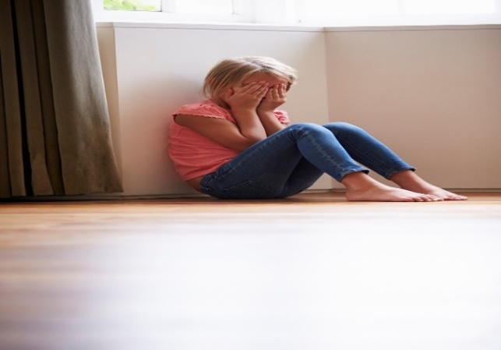Emerging robust evidence shows a relationship between childhood neglect, substance misuse, Child sexual exploitation, children missing from home and education, and vulnerability to gang involvement. Early intervention can mitigate the consequences of such adversity.

**Sudden and Unexpected Deaths in Infancy (SUDI)**

A recent review of SUDI by the National Child Safeguarding Practice Review Panel[1] highlighted that almost all of the incidents of SUDI notified to the Panel involved parents co-sleeping in unsafe sleep environments with infants, often when parents had consumed alcohol or drugs. In addition, there were wider safeguarding concerns including cumulative neglect, domestic abuse, parental mental health concerns and substance misuse.

Information relating to infant mortality in England highlights the relationship between infant mortality and the deprivation deciles in England. The latest IMD (2019) shows Oldham to be 19th most deprived out of 317 local authorities. Oldham’s infant mortality rate has been consistently higher than the North West and England rates for over a decade.

**Looked after children – returning home to families**

For many children, returning home from care is the best possible outcome. But research shows that for others this can result in further abuse or neglect (Holmes, 2014). Research commissioned by the independent review of children’s social care identified a number of societal factors which impacted the chances of successful reunification, including family poverty, lack of community resources, financial uncertainty, poor housing and a shortage of universal services (Hood et al, 2022).

Oldham Safeguarding Children Partners will consider the risks posed to a child, how much parents are able to change and their ability to protect their child from harm.

To ensure this is embedded in practice practitioners will:

* Be curious and challenging.
* Carry out assessments on significant adults. This will include the relationship with the child and the part they play in the care of the child.
* Have clear preparation for the return of the child
* Share information and work with professionals in other agencies
* Support and monitor the child and family before, during and after the return

**Youth Violence**

Young people within the criminal justice system are well evidenced as being likely to have a range of detrimental circumstances, which contribute to their journey onto offending. For example, a nationally representative study of almost 4,000 participants in England found that respondents with four or more Adverse Childhood Experiences **were seven times more likely to have been a victim of violence in the past year, and were eight times more likely to have committed a violent act** than those with no Adverse Childhood Experiences.[2]

Research is well established on the effects of trauma and adverse childhood experiences, which often intersect with issues of neglect and can contribute to young people becoming involved in criminality. [3]

Young people within the criminal justice system are also much more likely to be in care, with local evidence suggesting this ranges **between 7 and 12 times more likely in Oldham and up to 15 times more likely in national studies**. The underlying reasons for going into the care system are often linked to issues of neglect. [4]

These factors contribute to an increase in risk factors and vulnerabilities, meaning that young people who are subject to neglect are at risk of involvement in activity which results in criminal proceedings as an *offender* but also a range of behaviours that make them at risk of becoming a *victim* of crime; often these factors overlap for example in the case of criminal exploitation. In these instances, neglect can drive behaviour patterns that to the system present as *crime* but where in fact the underpinning reasons are *vulnerabilities.* This can contribute to further neglect, and abuse, through those in the community willing to exploit vulnerability.

In summary neglect plays a significant role, in conjunction with a range of other risk factors, in children’s pathway to offending behaviour. This is a complex issue, and we should be wary of ‘fatalistic’ models as many young people subject to neglect do not go on to commit crime however it is well evidenced as a contributory factor for young people within youth justice.

# What do children and young people say

# “If you see an unhappy kid, you should ask what is wrong” – young person

**We expect you to work hard to keep us safe**

**We expect to be included and involved**

**We expect to be informed.**

# Oldham Children and young people

# 

# We need immediate action to ensure that every child has access to a safe home, to enough food, to warm, suitable clothing. These are not obscene demands; these are the most basic of rights!!

# - Young female, NI

# … just speak to the children instead of the adults. Like the adults in our eyes, they only know what they’ve been told, whereas the kids actually know what’s like going on.

# Young male in care, England

# Towards the end you just get so numb…You’re just, it’s like you accept it. I learnt to accept it, if this is going to be my life then there’s no point in me complaining about it if I can’t do anything about it.

# -Young female living in a household with complex needs, England

# Poverty’s the main reason, yeah, why people get involved with bad things and that. So I don’t know how building more football clubs and all that stuff, yeah, is going to stop someone from being poor, innit? It’s not. You need money, innit? That’s the main reason why people do crimes, innit, for money?

# Young male in the youth justice system, England

# Neglect in Oldham

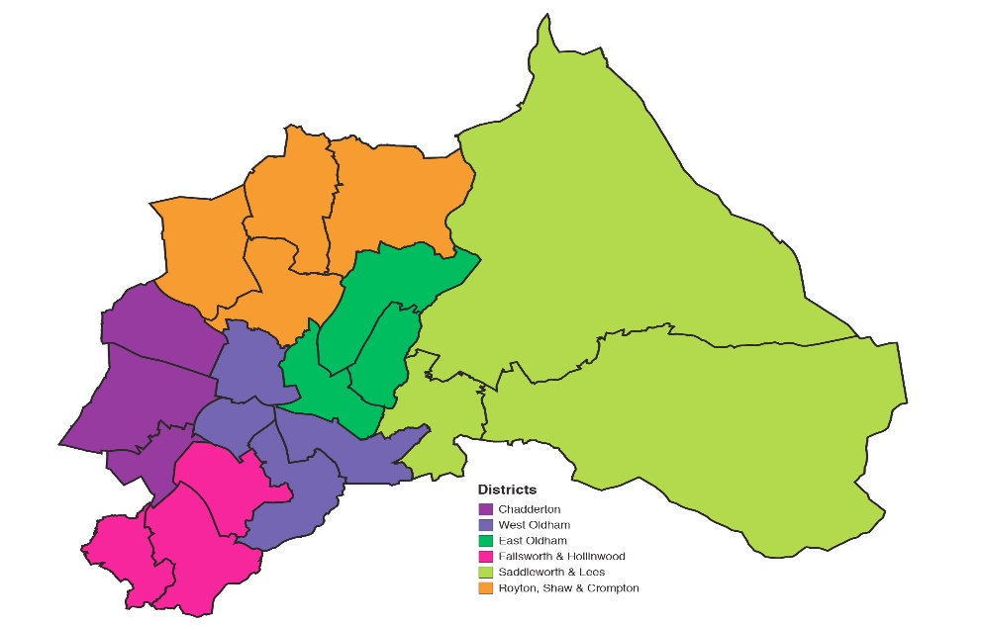

**As of 31 March 2020:**

1589 were open at Child in Need under the category of neglect

205 children were on a child protection plan under the category of neglect

346 children were looked after as a result of neglect

219 children in temporary accommodation.

Although levels of deprivation have improved in the borough, we are still ranked 47th highest out of 327 local authority areas. Four areas within Oldham are ranked amongst the top 1.1% of the nation’s most deprived areas.

The rate of children living in poverty has risen by 8.1% in four years. From 31.8% to 39.9%

**Of the young people known to YJS:**

28% have been a victim of parental/carer abuse

25% have a parent/carer with health or mental health problems

37% known to have witnessed domestic abuse

49% known to have experienced loss or bereavement

# Strategic ambition

**Prevention** ofthe causes that lead to child neglect rather than only responding to the symptoms by understanding the scale of neglect in Oldham and how it’s affecting our families.

**Protection** by ensuring a strong Partnership response with a common understanding of the spectrum of neglect and a recognition of the need to work with families at the earliest opportunity to prevent harm.

**Provision** of strengths-based support for families from voluntary and statutory organisations in Oldham

**Participation** by providing opportunities for children, young people and families to share their experiences in order to shape and develop our multi -agency response to neglect.

**Key Principles**

**Priorities for 2021-2025**

**We will work in partnership with families and communities to overcome factors which prevent parents/carers from meeting the needs of their children.**

**We will improve the awareness, understanding and the early identification of neglect through workforce development and communications**

**We will improve the quality of the multi-agency response to children and families living with neglect captured though case reviews, audit and voice of children and families**

**We will identify opportunities for children, young people and families to share their experiences in order to shape and develop our multi-agency response to neglect.**

**Appendix A – Examples of the GCP2**

**PHYSICAL CARE.**

|  |  |  |  |  |  |  |
| --- | --- | --- | --- | --- | --- | --- |
|  | **Area** | **Always met** | **Met** | **Met most of the time** | **Not met most of the time** | **Never met.** |
| **A1**  **1.1** | **Nutrition**  **Quality** | Parent/ carer is aware and proactive: provides excellent quality food and drink | Parent/carer is aware and manages to provide reasonable quality food and drink. | Parent/carer provides reasonable quality food but inconsistent through lack of awareness or effort. | Parent/carer mainly  provides poor quality fattening or sugary foods,  occasionally food is of  reasonable standards  if under pressure from  professionals | Quality not a consideration  at all or lies about quality |
| A2  2.2 | **Housing**  **Maintenance** | Exceptionally well  maintained. | Well maintained | Largely adequate, although  some areas of slight repair  required | In disrepair, despite the fact  that the parent could fix it | Dangerous disrepair despite being allowed to repair things themselves, exposed nails,  live wires etc. |
| A3  3.3 | **Clothing**  **Look** | Clothing exceptionally  well cared for, cleaned, and ironed. | Clothes well cared  for and clean | Most of the time the  clothing is adequately cared for although sometimes not clean. | Most of the time the clothes are dirty, crumpled and not cared for. | The child’s clothes are dirty, worn, crumpled and  in disrepair. |
| A4  4.1 | **Hygiene**  **Age 5-10** | Parent/carer takes an active role in hygiene needs; child is supervised, encouraged and impeccably clean. | Parent/carer helps as  needed; child is clean. | Most of the time the child  is clean — occasionally dirty with lapses in parental involvement | Most of the time, little  parental involvement  in child’s hygiene needs,  the child is dirty or smelly. | Parent/carer shows no  concern or awareness,  child is dirty and smelly |
| A5  5.3 | **Health**  **Health and development checks** | Visits clinic regularly; parent/carer seeks advice in addition to scheduled health checks. Up to date  with immunisations. Visits dentist and optician as appropriate | Up to date with health  and developmental checks including immunisations.  Up to date with dental and optician visits. | Up to date with most  of the child’s health and  developmental checks but needs to be reminded. Same for dentist and optician. | Child rarely attends health and developmental checks due to lack of awareness or motivation on part of the parent/carer. Needs  to be constantly reminded  and checking to ensure  attendance. Same for dentist and optician | Only seeks help if child becomes seriously ill or not at all. Even home visits are not accepted by parents/carer or avoided. |

**Appendix B – Resilience Factors**

Gerhardt (2014) suggests that we develop resilience pathways through experiences, such as if we live with anger and aggression for instance, we will learn to be alert for it. This stress response releases cortisol and high levels of cortisol in childhood has been linked to adverse outcomes in later life including adults who can’t respond to stressful events, aggressive behaviours and even links to obesity and heart disease (Loman and Gunnar 2010, Gerdhart 2014, Developing child 2010).

Therefore, it is important to not only recognise adverse circumstances for children, but also highlight positive factors within the child’s lived experience, as this can help to enhance existing capabilities and encourage optimal outcomes (Zolkoski and Bullock 2012).

**Individual Factors (child health and development)** [5]

• assertiveness

• ability to solve problems

• self-efficacy

• ability to live with uncertainty

• self-awareness

• a positive outlook

• empathy for others

• having goals and aspirations

• ability to maintain a balance between independence and dependence on others

• appropriate use of or abstinence from substances like alcohol and drugs

• a sense of humour

• a sense of duty (to others or self, depending on the culture)

**Relationships Factors (Parenting capacity/wider family)**

• parenting that meets the child's needs

• appropriate emotional expression and parental monitoring within the family

• social competence

• the presence of a positive mentor and role models

• meaningful relationships with others at school, home, and perceived social support

• peer group acceptance

**Community Factors (Environmental factors)**

• opportunities for age-appropriate work

• avoidance of exposure to violence in one's family, community, and with peers

• government provision for children's safety, recreation, housing, and jobs when they are at the appropriate age to work

• meaningful rights of passage with an appropriate amount of risk

• tolerance of high-risk and problem behaviour

• safety and security

• perceived social equity

• access to school and education, information, and learning resources

**Cultural Factors (child health and development/wider family/identity)**

• affiliation with a religious organization

• tolerance for different ideologies and beliefs

• adequate management of cultural dislocation and a change or shift in values

• self-betterment

• having a life philosophy

• cultural and/or spiritual identification

• being culturally grounded by knowing where you come from and being part of a cultural tradition that is expressed through daily activities

**Physical Ecology Factors (environmental factors)**

• access to a healthy environment

• security in one’s community

• access to recreational spaces

• sustainable resources

• ecological diversity

**Digital resilience**

* Children and Young People **understand** when they are at risk online and can make informed decisions about the digital space that they are in
* Children and Young People **know** what to do to seek help from a range of appropriate sources
* Children and Young People can **recover** when things go wrong online by receiving the appropriate level of support to aid recovery
* Children and Young People **learn** from their experiences and are able to adapt their future choices where possible

**References**

1. <https://www.gov.uk/government/publications/safeguarding-children-at-risk-from-sudden-unexpected-infant-death>
2. <https://cycj.org.uk/wpcontent/uploads/2018/08/Adverse-Childhood-Experiences-in-high-risk_CYCJ-_Final-Version-proofed.pdf>
3. <http://www.beyondyouthcustody.net/wp-content/uploads/Trauma-and-young-offenders-a-review-of-the-research-and-practice-literature.pdf>
4. <https://assets.publishing.service.gov.uk/government/uploads/system/uploads/attachment_data/file/543582/YJB_response_Laming_Review_keeping_children_in_care_out_of_custody.pdf>
5. Fox, J, Leech, J and Roberts, E (2014), [Supporting Emotional Resilience within Social workers](https://www.rip.org.uk/~ftp_user/supporting_emotional_resilience_within_social_workers/files/assets/common/downloads/supporting_emotional_resilience_within_social_workers.pdf), Research into Practice: Dartington

   <https://www.researchinpractice.org.uk/umbraco/null>