

**OLDHAM SAFEGUARDING**

**CHILDREN PARTNERSHIP**

**STRATEGIC PLAN 2024 - 2027**

This Strategic plan is a public document.

It can be accessed on the website of Oldham Safeguarding Children Partnership: <https://www.olscb.org/about/publications/>

Approved by OSCP on XXXXXXXXX 2024

Contact details:

OSCP Business Manager Rock Street resource centre Rock St

Oldham OL1 3UJ

0161 770 1524

Availability and accessibility: if you would like to receive this report in any other format please contact us at the address above.

# Foreword

The Oldham Safeguarding Children Strategic Plan for 2024-27 has been developed to ensure it is compliant with Working Together 2023, and The National Framework for Childrens Social Care and to reflect the changing strategic needs within Oldham. The Multi-Agency Safeguarding Arrangements set out our ambition. In January 2024, the Partnership came together to agree our strategic priorities for 2024-2027. Oldham Safeguarding Children Partnership (OSCP) want to embrace the possibilities of Working Together 2023 including the way we ensure the community and voluntary sector, and Schools are given more of a role in setting the strategic direction of OSCP. Our key need is to ensure we ‘close the loop’ on learning from quantitative (Performance information) and qualitative (audits and case reviews) data to drive improvements in our strategic priorities, set out below. We will use the Quality Assurance Framework to scrutinise and challenge the services in Oldham. A key success measure will be to ensure our workforce are equipped with the right training and tools, and will be a confident, trauma informed workforce operating systemic practice. The Partnership will support the training offer to target our strategic needs through our refreshed workforce strategy and pool of trainers. We have developed a new Quality Assurance Framework which will inform quicker identification and response to emerging needs. It is underpinned by an outcome focused approach (success criteria) and robust governance. The safeguarding partners are committed to continuing a culture of continuing learning and improvement and give the public confidence that children in the borough are effectively safeguarded and protected.

**Gerard Jones Andrea Edmondson Estelle Mathieson**

Director of Childrens Services Assistant Director Quality, Chief Superintendent

Oldham Council Safety & Safeguarding Oldham Director Commander Oldham

GM – ICB Greater Manchester Police

## Oldham’s Context

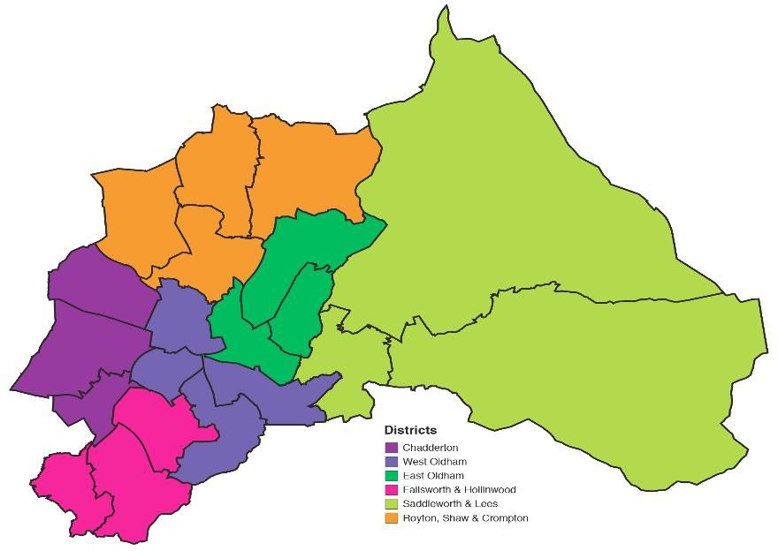

Oldham has a diverse population with 32% of residents from Black, Asian and Minority ethnic groups (BAME).

Almost two-fifths (38%) of children under 16 in Oldham live in poverty.

Oldham is ranked 19th most deprived out of 317 local authority areas. Four areas within Oldham are ranked amongst the top 1.1% of the nation’s most deprived areas.

There are 61,000 children and young people aged 0-17 (25% of Oldham’s population). Numbers of children and young people are projected to fall by 5% over the next decade.

Oldham has a population of 246,130 people making it the 6th largest borough in Greater Manchester.

In 2023/24 there were:

* 5,430 referrals to children’s services
* 533 child protection conferences initiated
* There are over 550 Children Looked after in Oldham
* 5,430 referrals to children’s services in 2023/34
* 533 child protection conferences initiated in 2023/24
* There are over 500 children looked after in Oldham

## Our Vision

***“For everyone to work together to ensure that all children and young people are safe and feel safe within their homes, schools and communities.”***

This vision is underpinned by the strategic aims and priorities identified throughout the strategic plan for 2024-2027. It supports the principle that safeguarding is everyone’s business and reinforces the need for us all to work together in order to support children and young people in Oldham to achieve their full potential.

## Our Purpose

OSCP brings together the Statutory Safeguarding Partners (Greater Manchester Police, Greater Manchester Integrated Care Board and Local Authority) to work in close collaboration with Relevant Agencies to safeguard and promote the welfare of all children and young people in Oldham. This is achieved through the co-ordination of collaborative partnership activity at a local level to identify and respond to local safeguarding need, ensure local arrangements for the safeguarding of children are fit for purpose and provide scrutiny of, and challenge to, those arrangements where appropriate.

## Our Strategic Aims

1. Excellent practice is the norm across all practitioners in Oldham.
2. Partner agencies hold one another to account effectively and escalate where necessary.
3. Children get the right help, at the right time by the right people at the earliest opportunity.
4. A culture of learning and workforce development is embedded across the children’s workforce.
5. Information is shared effectively to promote the safeguarding of children.
6. The public feel confident that children are safeguarded and protected.

## Our Principles

Child's lived experience is central

Work together and learn together

Collaborative engagement with families and communities

Earliest possible help and support

# What we delivered. Strategic Plan 2021- 2024.

### Domestic Abuse

We developed a robust local offer to children and families who are at risk of, or experiencing, domestic abuse which offers early help, protection and reduces the impact of their experiences. There are a range of interventions and measures available, and these are used to reduce the risk presented by perpetrators of domestic abuse. The Partnership workforce through a robust coordinated partnership training programme, have developed key knowledge and a skill set in relation to domestic abuse.

We will continue our commitment to an aligned preventative approach for those who are at risk of becoming perpetrators. We have developed a multi-agency system that is joined up for individuals, families and communities.

This focus on domestic abuse will continue to be important to OSCP moving forward.

The Ofsted inspection in May 2024 recognised that the response to domestic abuse referrals is well embedded in the MASH. Contacts are managed sensitively to mitigate risk to victims, using the support of the independent domestic violence adviser for adults and children. Social workers obtain information from key agencies, which leads to clear analysis of risk to inform the immediate and ongoing safety planning for most children.

### Complex and Contextual approach to Complex Safeguarding

### We have strengthened our offer to children and young people at risk of or experiencing all forms of exploitation to ensure they have received the right support at the right time in order to keep them safe. We have built capacity in all areas of the statutory partnership and community partners to be able to recognise and respond to all forms of complex and contextual safeguarding that affect the lives of children and families.

### Whilst the dedicated multi-agency all age complex safeguarding hub is a real strength for the Partnership there will be a continued focus on the mapping and development of the community level support offer, development of a robust multi-agency response to criminal exploitation and gangs and the embedding of our contextual approach to complex safeguarding.

### The Ofsted inspection in May 2024 recognised that the support provided by the complex safeguarding team continues to be strong. Leaders have sustained a good level of service in early help and at the ‘front door’, despite increased levels of demand.

### Transitions

### OSCP are committed to planning at the earliest possible stage for the transition of children and young people who will require services in young adulthood, ensuring robust outcomes.

### A transitions strategy which is founded on a principle of preventative and strengths-based practice has facilitated an offer of services that from the perspective of the young person and their family is positive and seamless, aligning with their aspirations.

### The strategy includes key partner agencies who have a role within transitions, and to areas of safeguarding that had been identified as priorities such as complex safeguarding and mental health.

### Children’s mental health and understanding the impact of trauma.

### The partnership supports healthy emotional development and helps children and young people to become thriving adults.

### Our commitment is to support children and young people living with mental ill health and/or the impact of trauma to be able to access the right level of support at the right time. This included caring for the most vulnerable with appropriate mental health support through services working together. This is reflected in the Mental Health Strategy. Accountability and governance have been a key priority for Partners.

### Partnership agencies have continuously invested in the creation of a workforce which understands how to use early intervention to prevent lifelong trauma, and how to help children and families recover from the impact previous trauma has on their lives.

### Neglect

Neglect in childhood can affect lifelong outcomes. OSCP agreed this as a priority to ensure there would be a clear and robust offer of support at the earliest opportunity, balanced with child centered intervention and protection if required, narrowing the gap to reduce the numbers of children living in poverty.

Whilst we made some progress around developing the tools to support reducing neglect, enhanced our adolescent offer, and rolled our training for the partnership workforce, we still feel we have work to do.

# How our priority areas were developed 2024- 2027.

In July 2024, Oldham Safeguarding Children Partnership held a conference for agencies and professionals who have a role in Oldham to help keep our children safe. The day reflected on the OSCP priorities, embedding Working Together 2023 and learning from serious case reviews.

**Priorities 20-24.**

The priorities for 2020- 2024 were presented, reviewed, and discussed to look at what emerging gaps and areas for improvement should form part of the OSCP business plan for 2024 – 2027.

**Learning from serious child safeguarding incidents**

It was identified that there were 4 emerging themes in Oldham.

* Sexual Abuse and Disclosures
* Voice of the Child
* Neglect and cumulative harm
* Serious Youth Violence

As a partnership, it was agreed that following the learning and themes identified from serious safeguarding incidents the priorities should be reconsidered. Feedback from the OFSTED inspection in May 2024 identified emerging gaps and areas of significant improvements. This also influenced the decision to review and update Oldham Safeguarding Children Partnership Priorities for 2024 – 2027.

# Our Priorities 2024-2027.

**1 Neglect**

There is strategic commitment to elevate child and adolescent neglect. We will continue to develop a standardised approach which all partners will utilise to identify and respond to child neglect.

We want a community that will recognise and respond to neglect. We will have a confident and competent workforce will be who are able to recognise and respond to neglect at the earliest opportunity.

The Partnership will know there is a difference in children and young people’s lives because there will be a reduction in the need for children to be open to Childrens Social Care including on a child protection plan and or/in care proceedings.

**2 Responding to need at the right time – application of thresholds, roles and responsibilities.**

In Oldham we have recognised that early intervention is vital to ensure we provide target support services at the earliest opportunity for all children and their families who live in Oldham. We want to ensure Oldham Safeguarding Children Partnership offer a clear framework and have a common understanding of support levels of need for practitioners within all agencies. All partners will fully understand their roles and responsibilities. Agencies will identify a child’s need and respond with the approach of ‘the right help at the right time’.

In Oldham we have recognised a rise in the number of sexual abuse cases. Children and young people who have access to local services and the right help at the right time will have opportunities to disclose whilst services will be alert to signs of abuse.

**3** **Developing a multi- agency practice model. The way we work with families (strength based) to ensure all families in our communities' access advice, support, and protection.**

In Oldham we aim to offer a safe place for children to grow up happy, healthy, confident and ambitious. We want children to grow up in a loving and caring environment and to be able to have the very best start in life. We want families to be supported where necessary to provide this.

All agencies working with children and families play an integral role in achieve this.

The multi-agency practice model will strengthen the way we work with families to ensure all families in our communities’ access advice, support and protection.

The practice model will ensure agencies and professionals working with children and families understand the role they play in ensuring children and families right level of advice, support and response at times of need.

**4 Serious Youth Violence.**

We recognise the clear link between exploitation and youth violence. Our partnership will offer support to children at the earliest opportunity to divert them from criminal justice pathways and associated risks. When children enter the criminal justice system, we work within a child-first approach, focusing on the root causes of behaviour, including factors relating to exploitation.’

### Working with Other Partnerships

# Governance, Quality and Effectiveness.

We will provide assurance in judging the effectiveness of multi-agency arrangements to safeguard and promote the welfare of all children. This includes producing and maintaining oversight of the QA framework. We will scrutinise performance indicators and evidence activities such as learning events and 7-minute briefings to support thematic learning.

Oldham local authority children’s service was inspected in May 2024.

The inspection identified that since the last inspection in March 2019, when services for children and families were judged to be requires improvement to be good, there has been a relentless focus on

improvement, driven by the director of children’s services and his strong and stable leadership team. The pace of change has been purposeful and has ensured that children now benefit from good-quality help and support. Most children’s outcomes improve as a result of family-focused, child-centred practice, which is increasingly aligned to a new model of practice.

The inspection report highlights:

“Improved professional relationships across the partnership enable leaders to set high expectations and standards of themselves and their staff. There are clear lines of accountability and there is a culture of being able to safely challenge partner agencies. Positive feedback from Cafcass and the family judiciary

highlights that senior leaders work successfully with their partners.”

Although there are further development plans in place for the partnership, the overall outcome of good indicates that OSCP are working together effectively to safeguarding children and young people in Oldham.

# Our Model

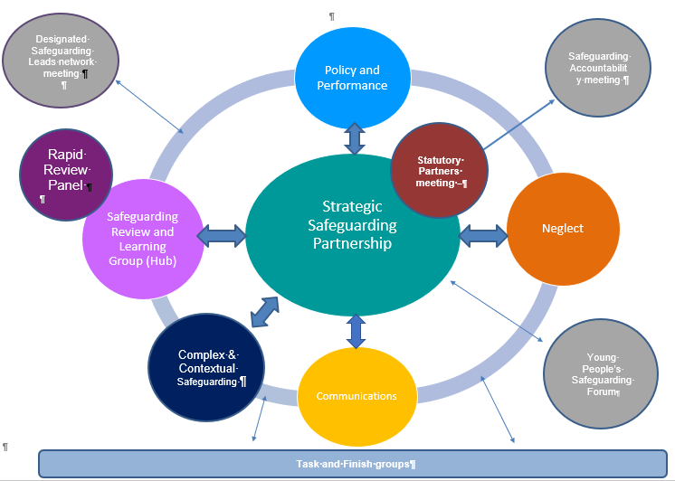

**Safeguarding Accountability meeting:**

Quarterly meeting to provide safeguarding assurance to the Leader of the Council.

**Performance Co-ordination:**

* Deliver a performance framework and scorecard that is focused on improving outcomes for children

**Rapid Review Panel**

* This is an agreed subset of the Safeguarding and Learning Review Group which will pulled together as and when required to respond to rapid review referrals.
* Recommendations from the Panel will be made to the Safeguarding Review and Learning Group to progress.

**Statutory Partner meeting**

* To agree the agenda for the Partnership
* To receive exception reports from subgroup chairs
* To prepare for Safeguarding Accountability meeting
* To identify cross cutting themes with the Adult Safeguarding Board

**Strategic Safeguarding Partnership:**

* Setting the strategic aims and priorities of the Oldham safeguarding children partnership,
* Agreeing and monitoring the partnership budget to deliver on those aims and priorities,
* Monitoring the performance scorecard of the partnership,
* Holding partners to account in relation to their safeguarding responsibilities
* Providing scrutiny and challenge to partners

**Safeguarding Review and Learning Group:**

* To define “what good looks like”
* To facilitate the effective management of Child Safeguarding Reviews
* To act as a conduit at a local level for the delivery of any national reviews
* To audit and evaluate the impact of learning on partnership practice
* To develop and drive the partnership training plan, influenced by strategic priorities and learning from reviews
* To develop a culture of continuous learning and improvement across the Partnership to safeguard and promote the welfare of children and promote good practice.

**Designated Safeguarding Leads Network:**

* Held termly with DSL’s to ensure communication and discussion with schools/colleges

**Task and Finish groups**

* To lead on time limited, task specific pieces of work as directed by subgroups and/or Strategic Partnership

**Communications:**

* Develop communications strategy for Partnership
* Lead on cascading of information to wider professionals and communities
* Engage children and young people in the work of the Partnership
* Support Partnership in relation to media interest relating to Partnership activity

**Policy and Procedures (Virtual Group):**

* Develop and implement appropriate thresholds, policies and procedures that are focussed on improving outcomes for children and families

**Young people’s safeguarding forum:**

* Themed focus groups led by Oldham Youth Voice Family and promoted to children and young people across Oldham.
* To consult on Safeguarding themes and feedback to the Strategic Safeguarding Partnership
* To support priority setting for the Partnership