.

Oldham Safeguarding Children Partnership

Educational Neglect Policy

September 2023
1 Introduction and Background

Oldham Local Authority over the years has prosecuted many families under the offence of Section 444 Education Act 1996 multiple times often due to where the children have been severely or persistently absence from school for either the same pupil or siblings and/or involving the same parents. Also, in more recent years Oldham has faced the challenges of prosecuting families after they have failed to ensure that their child is receipt of an education other than at school (this including Children Missing from Education (CME) or those deemed not receiving suitable education through being electively home schooled (EHE)) and having failed to register their child at a school after an Attendance Order and being prosecuted under the offence Section 443 Education Act 1996. There is concern that for a number of families there have been multiple prosecutions and that Oldham Local Authority has below national average attendance, therefore there are behaviours for some of these children / families that are not changing over time.

Many reports over the years have found links between neglect and poor school attendance. The Department of Education in 2012 accepted a recommendation that ‘persistent failure to send children to school is a clear sign of neglect and that children’s social care services should work with schools to address underlying difficulties’ (https://assets.publishing.service.gov.uk/government/uploads/system/uploads/attachment_data/file/180772/DFE-00036-2012_improving_attendance_at_school.pdf).

The NSPCC in 2013 cited that ‘failure to ensure regular attendance that prevents the child reaching their full potential academically’ as one of their six forms of neglect.

Neglect is “the ongoing failure to meet a child’s basic physical and psychological needs” (Department for Education, 2018; Department of Health, 2017; Scottish Government, 2014; Wales Safeguarding Procedures Project Board, 2019).

Educational neglect – involves a carer failing to provide a stimulating environment, show an interest in the child’s education at school, support their learning, or respond to any special needs, as well as failing to comply with state requirements regarding school attendance. (Howarth (2007)).

This policy aims to highlight and consider the term Educational Neglect as a descripter within a continuum of need for a child. Educational Neglect would be considered as a critical state beyond ‘persistent absence,’ to support schools consider and convey the level of concern of continued persistent absence for individual children where prosecution has not assisted in raising their attendance. Consideration of Educational Neglect highlights a level of need that requires further assessment to consider the impact of continued persistent low school attendance upon children. Educational Neglect has been highlighted as an area of need which requires consideration within numerous reports, which provide context of the concerns for a child. The term ‘educational neglect’ was considered as being the most helpful, in that it could both support the narrative from professionals as well as simply convey to our school communities the level of concern the issue should invoke.
This is supported by DfE guidance ‘Working together to improve school attendance’ and through serious case reviews such as Child M Birmingham.

The policy builds on research developed by Knowsley Council where they had previously considered ‘safeguarding and long-term’ absence and compiled Educational Neglect definitions and statutory pathways.

By highlighting the term educational neglect, it is not intended to necessarily increase the traffic of social care referrals. There is a clear expectation that schools should have used the below strategies prior to a referral for Educational Neglect:
- Evidence school have followed their own attendance policy
- Spoken to each child and/or parent/carer to ascertain reasons for absences
- Considered requesting Penalty Notice procedures
- Spoken to LA Attendance Officer regarding child for advice
- Arrange an Attendance panel / fast track meeting with parent/s offering support via early help assessment
- Should parent/s not engage with early help assessment evidence of all offers of support / attempts to engage within chronology, have evidence of consistent attempts to reach out to parents
- If there are issues of anxiety raised / patterns of absence include possibly psychosomatic reasons that could be contributed to anxiety (tummy ache / head ache etc) Consider EBSA and EBSA toolkit as means of providing support
It has been acknowledged that several young people that had failed to attend school regularly and where there have been multiple prosecutions through the magistrate’s courts by the Inclusion Service and a limited number of electively home-schooled cases were already and/or previously on the caseload of Social Care.

2 Educational Neglect Definitions

The definitions for Educational Neglect are detailed below, however it must be noted that where irregular school attendance or not receiving suitable education through elective home schooling (EHE) are the only presenting or significant issues, evidence must be collated over a twelve-month period, or in the case of EHE pupils during the period that the local authority officers have taken all reasonable steps to establish whether suitable education is being received and has also resulted in statutory action.

Where Educational Neglect appears to be the sole presenting issue through irregular school attendance or not receiving a suitable education through EHE then all involved professionals must collate a chronology of all offered support, interventions, evidenced observations and actions will have ordinarily taken place over a period of 12 month period.

‘Working together to safeguard children’ provides a neglect description, ‘The persistent failure to meet a child’s basic physical and/or psychological needs, likely to result in the serious impairment of the child’s health or development’, and this forms the basis of the following definitions.

Escalation Pathway
Any concerns about Education Neglect issue can be raised via the Weekly online Inclusion/Senco drop-in, at school’s targeted support meeting or a direct conversation with the Inclusion Manager or the Safeguarding Advisor for Education.
Where there is a need to escalate through childrens social care the Inclusion Manager or the Safeguarding Advisor for Education will raise the matter with the team managers and Assistant Director’s where appropriate.

Certain risk factors necessitate immediate referral to the Duty and Advice Team (MASH).

Schools should always refer to their Safeguarding/child protection Policy.

3 Definition of Educational Neglect
(Omission by Parent)

Educational threshold for ‘persistent failure’ requires all the following to be met over a twelve-month period:

- Parent failing or inadequately maintaining schooling or identifying provision for their child;
- Parent failing to attend most school and LA meetings and/or engage with support offered;
- Parent unable to provide substantiated reasons for most absences from school; and
- At least one court intervention which fails to improve attendance i.e. Section 444/4441A prosecution or School Attendance Order or Education Supervision Order.

Educational threshold for ‘serious impairment of development’

- Primary aged children where school attendance is 75% or less over an academic year (three terms), as this half the possibility of achieving Level 4, the recognised average level for a child at the end of KS2 (2013/14 national research).
- Secondary aged young people where school attendance is 75% or less over an academic year (three terms), as this means the young person is five times less likely to achieve 5 GCSE’s including English and Mathematics, the recognised average level for a young person at the end of KS4 (2013/14 national research).

Oldham definition of Educational Neglect (omission by parent) has been met if there is evidence of both thresholds.
4 Definition of Educational Neglect
(Omission by the Young Person)

This definition is appropriate when pupils are old enough to determine their own actions and independently travel to school and where:
- parental co-operation is clearly demonstrated;
- current educational provision is appropriate for the young person’s needs; and
- attendance levels are as identified above (threshold for serious impairment of development).

Should these thresholds be met, the Inclusion Team will consider applying to the Family Court for an Education Supervision Order. If the young person or parent persistently fails to follow any directions made in the course of an Education Supervision Order, there is a duty for an early help/social care to assess the child’s circumstances.

5 Individual Attendance Rate Thresholds Over 12 Months
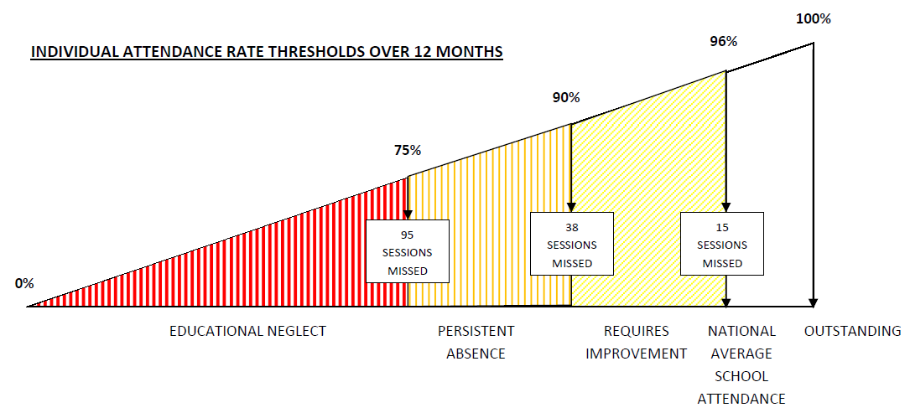

6 Statutory Pathways

Education Penalty Notices (Administered by Local Authority)

These are used as an early intervention where there is irregular attendance, unauthorised absence and a reasonable expectation that this may change; discharges the parent’s liability for conviction of an offence by paying under the Education (Penalty Notices) (England) Regulation 2007.

Prosecution – Absolute Offence (Magistrates Court)

Prosecution of a parent, under Section 444(1) of the Education Act 1996, for irregular attendance of child with unauthorised absence; this is a strict liability offence with limited defences.

Prosecution – Aggravated Offence (Magistrates Court)

Prosecution of a parent, under Section 444(1A) of the Education Act 1996, for irregular attendance of child with unauthorised absence; parent knows about the irregular attendance and fails without reasonable justification to change this; potential of custodial sentence.

School Attendance Order (Magistrates Court if not resolved)

Requires parent(S), under Education Act 1997 to register a child of compulsory school age at a named school when not receiving a suitable education.

Education Supervision Order (Family Court)
12-month Order under Section 36 of the Children Act 1989 on the grounds that the child is not being suitably educated; Supervising Officer to, ‘assist, advise and befriend’.

7 Summary

This policy has been written to support in the protecting of all Oldham children and young people from Educational Neglect which is often described as an understudied phenomenon that is difficult to define and to address.

Here in Oldham our aim is to address educational neglect by having a policy that clearly defines how all services such as education, social care, health and all other professionals respond to allegations of educational neglect.

Oldham Local Authority wish to acknowledge the document by Knowsley Council which this policy has evolved from:

EDUCATIONAL NEGLECT DEFINITIONS AND STATUTORY PATHWAYS

Neglect
(omission by Parent)
Neglect
(omission by Young Person)

Preventative Measures:
Early Help
LA Action
Applied & Successful in Improving Attendance

Preventative Measures: Applied & Successful
Measures Successful Attendance Improved
Yes
No
No
No
Inclusion Team consider ESO
Early Help Assessment
EH Assessment
No
EH Assessment
Conditions met for Educational Neglect
Persistant Failure
Serious Impairment
EH Assessment
EH Assessment

YES
No
Duty and Advice(MASH) Referral by Inclusion Team
CSC carries out Single Assessment
Inclusion Team continue Support/ Action

