**Dispute Resolution Pathway**

Communication throughout any dispute remains the key priority – ensuring that direct discussion is the primary remit of communication, and this is an understanding by all representatives. **This pathway should be followed wherever practitioner to practitioner resolution has not been effective**. Agreed outcomes will be recorded and shared via email to ensure decision making captured on each agency’s electronic recording system.

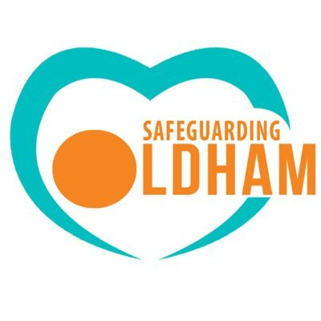

**Stage 1:** Direct informal discussion should be held between the relevant team managers or agency equivalent as a first option to try to resolve any dispute. This should be held through either telephone or face to face discussion as a priority and key points confirmed in writing, including in the Subject ‘Stage 1 discussion following the partnership resolution policy’.

If following informal discussion between team managers, a resolution has not been agreed between agencies, to convene a resolution meeting involving relevant agencies and IRO if involving a child who is looked after. (*Appendix 1&2 includes agenda template and minutes template*)

**Stage 1:** Team Manager or agency equivalent

**Stage 2:** If through the resolution meeting between team managers and relevant agencies, an agreement cannot be reached, then contact will need to be established between allocated senior manager or head of service within 5 working days. Minutes from resolution meeting to be shared with head of service/ allocated senior manager. When confirmed in writing, including in the subject ‘Stage 2 escalation following the partnership resolution policy’.

**Stage 2:** Head of Service or agency equivalent

**Stage 3:** If stage 2 has not been successful and a resolution has not been achieved then responsibility will transfer to the responsible Assistant Director/Senior Manager to seek direct discussion in order to achieve resolution. Focus again will remain consistent on direct discussion first and foremost.

**Stage 3:** Assistant Director or agency equivalent

**Stage 4:** If at any point risk escalates or resolution cannot be achieved, engagement with Oldham Safeguarding Partnership and contact made with the Business Manager so that the senior statutory partners can be involved. To share any minutes from resolution meetings held earlier in the process.

**Stage 4:** Escalation to Oldham Safeguarding Partnership