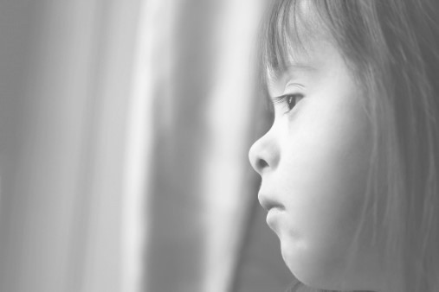
Safeguarding children means protecting the most vulnerable from abuse and neglect.

During the Covid-19 pandemic, professionals
and volunteers may come into contact with individuals and families they haven’t met
before.

If you see something, are told something or something doesn’t feel right you need to report it.

Call Oldham’s Multi Agency Safeguarding Hub
on 0161 770 7777 .

Out of office hours contact 0161 770 6936

Don’t ignore it, report it.
For more information visit https://www.oldham.gov.uk/lscb/
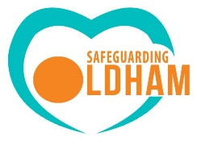 With thanks to Rochdale Safeguarding Children Partnership

